NFL Player Salaries vs. On-Field Performance: Unraveling the Correlation
Cathy T. Millan
Department of Information Systems, Park University
CIS606: Applied Data Mining Analysis of Big Data
Professor Amelia Maples
October 6th, 2023

NFL Player Salaries vs. On-Field Performance: Unraveling the Correlation
This study's primary research question is to investigate whether a correlation exists between player performance metrics, explicitly passing yards and touchdowns, and player salaries in the NFL. To address this question, several vital variables are essential for analysis. Firstly, we need data on player salaries, including total contract salary, annual salary, signing bonuses, and base salary, as these represent the financial compensation received by NFL players.
Secondly, player performance metrics, such as passing yards and touchdowns, are critical variables that reflect on-field contributions. Additionally, the dataset should include information on player positions, as different positions come with varying salary expectations and performance standards. Lastly, the dataset must be organized by season or year, enabling us to track changes and trends in player salaries and performance over time. By examining these variables, we aim to shed light on the complex relationship between player compensation and their on-field achievements in the NFL.
Datasets Description
NFL Player Statistics Dataset
This dataset contains detailed performance metrics for NFL players, such as passing yards, touchdowns, interceptions, rushing yards, and other statistical categories, broken down by season and player in 47,991 rows.
NFL Team Stats: https://query.data.world/s/cwnty2cok75km3hyemnfi3ejdrdbjy?dws=00000
NFL Play by-Play Data: https://raw.githubusercontent.com/ryurko/nflscrapR-data/master/play_by_play_data/regular_season/reg_pbp_2019.csv
https://raw.githubusercontent.com/ryurko/nflscrapR-data/master/play_by_play_data/regular_season/reg_pbp_2012.csv
https://ryurko.github.io/nflscrapR-data/
NFL Player Salary Dataset
This dataset includes information on NFL player salaries, amount paid at sign-on, total contract salary, and annual salary, broken down by player, position, and year. It often includes base salary, signing bonuses, and other forms of compensation in 16 columns and 11 872 rows.
NFL Salary Dataset: https://query.data.world/s/cjkbplx6udzft56e5we7dagudrrrow?dws=00000
Description of Analytical Techniques
The research analyzes the correlation between NFL player salaries and their on-field performance. This entails a deep dive into multiple datasets, encompassing performance metrics like passing yards, touchdowns, and salary details. The Python library used “Pandas” was the most suited technology for powerful data manipulation capabilities. The analytical techniques employed include:
- Data Cleaning: Ensuring data quality is paramount. Combined with the Pandas Library, Python is employed for tasks like removing duplicates, handling missing values, inputting placeholders, addressing discrepancies in team naming conventions, and converting data types.
- Data Merging: Given that insights are to be derived from multiple datasets, a robust merging strategy is employed through "mapping ."The datasets are linked using identifiers such as "NormalizedTeams” and “NormalizedTeams_offense/defense.” Relevant variables were merged into a single data frame to include 'TotalPassingYards,' 'TotalTouchdowns,' and 'ACTIVE' for active team salary.
- Correlation Analysis: At the heart of the research is the application of correlation analysis. This statistical technique evaluates the strength and direction of linear relationships between pairs of variables. We will compute Pearson's correlation coefficients to measure the relationships between:
- Total passing yards and active team salary
- Total touchdowns and active team salary
This will give us understanding of whether there is a linear relationship between team performance metrics and salaries.
Parallelization Technologies Used
- Cloud Computing:
  - Platform Used: The study utilized Microsoft Azure Cosmos DB and Microsoft
Azure Cloud for data management. These cloud platforms facilitate scalable computational resources, ensuring that large datasets and intensive processes run efficiently.
  - Integration with Big Data Tools: Azure's compatibility with distributed
computing platforms like Spark (via Azure Databricks) make it apt to handle extensive NFL datasets and perform parallel processing.
  - Virtualization: Azure provides the capability to provision multiple virtual
machines, thus ensuring parallelism and resource optimization.
- Multiprocessing:
  - Python's Role: The CPU-intensive tasks, especially during data cleaning and
statistical analyses are handled using Python.
  - Parallel Processing with Multiprocessing: Python's multiprocessing module
assists in distributing tasks across multiple CPU cores, amplifying the speed of operations, and optimizing computational efficiency.
  - Development Environment: Python scripts and methodologies were
implemented using Microsoft Visual Studios, which offers an integrated environment for development, debugging, and execution. Given the nature of the research, combining cloud computing and multiprocessing provides the computational backbone, ensuring efficient data management and timely analysis. Leveraging these parallelization technologies is not just a choice but a necessity, given the vastness of the datasets and the complexity of the operations involved.
Preliminary Analysis
For the preliminary analysis, correlation analysis was conducted to examine the relationships between various variables in the NFL datasets. Correlation analysis is a valuable technique to assess the strength and direction of linear relationships between pairs of variables. In this case, we wanted to understand how specific performance metrics (e.g., yards gained touchdowns) relate to player salaries and team performance.
RESULT
Yards IsTouchdown Total
Yards 1.000000 0.763612 0.521771
IsTouchdown 0.763612 1.000000 0.395148
Total 0.595059 0.485000 1.000000

This analysis will also use regression to predict ‘ACTIVE’ (team salary) based on performance metrics (TotalPassingYards and TotalTouchdowns).
Key Findings
- Total Passing Yards vs. Active Team Salary: The correlation coefficient is approximately 0.595059. This suggests a moderate positive linear relationship between the total passing yards of a team and its active salary. This means that, on average, teams that spend more on salaries tend to have higher passing yards.
Graph 1.
Total passing yards vs. active team salary
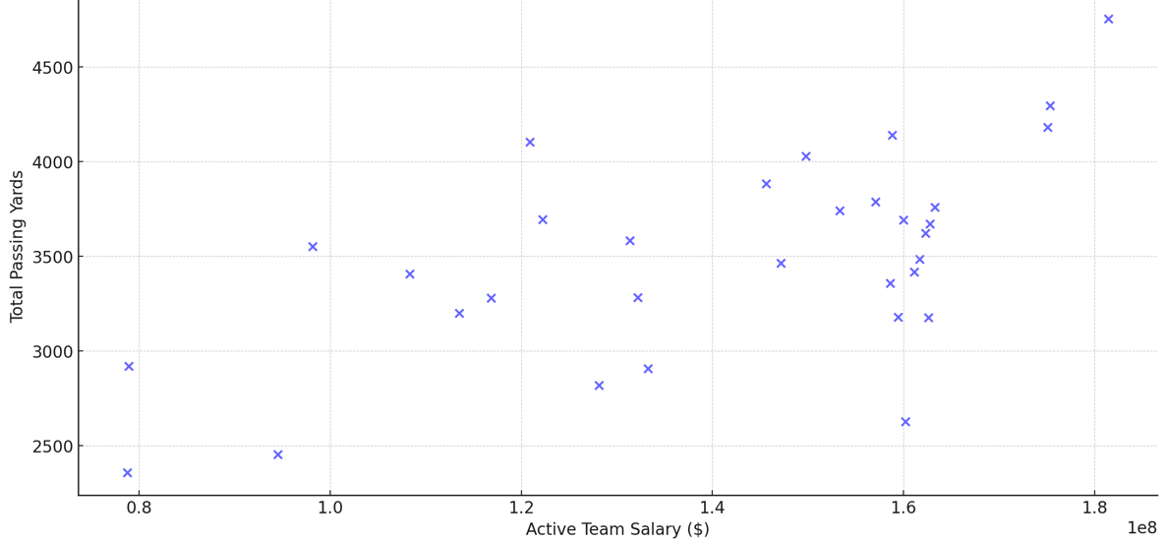
- Total Touchdowns vs. Active Team Salary: The correlation coefficient is approximately 0.4850. This indicates a moderate positive linear relationship between the total touchdowns of a team and its active salary; like the first metric, teams that spend more score more touchdowns through passing.
Graph 2.
Total Touchdowns vs. active team salary

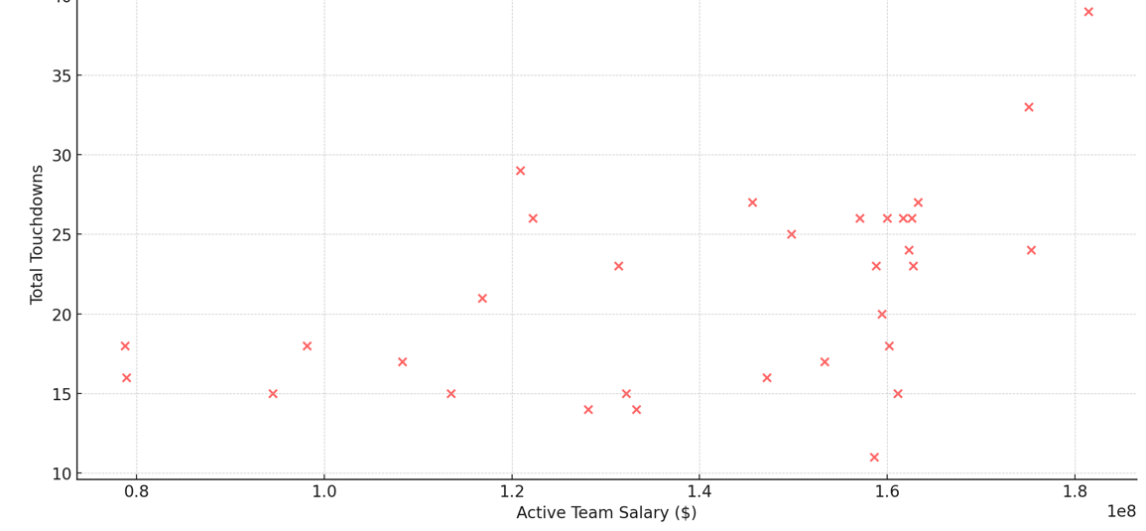

Interpretation and Implications
- Teams with players who have higher salaries tend to achieve more passing yards.
- Similarly, teams with higher-paid players tend to score more touchdowns, though the
strength of this relationship is weaker compared to passing yards.
The positive correlations indicate that teams investing more in their players (regarding salaries) generally see better performance metrics, such as passing yards and touchdowns (Graph 3). However, it is essential to note that correlation does not imply causation, and other factors might be at play. Further, the analysis is based on aggregated team data so that individual player performance can vary widely within teams.
Graph 3.
Correlation Matrix of Player Performance Metrics and Salaries
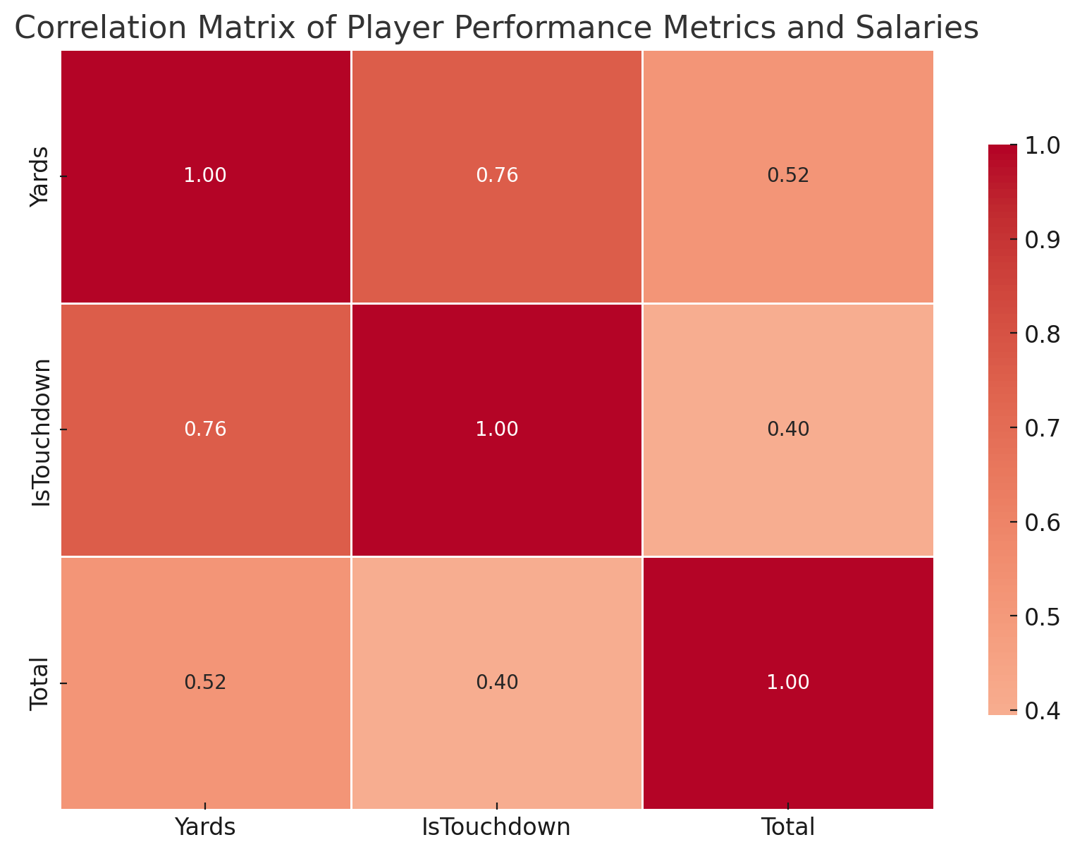
Problems the Analysis May Solve
The correlation analysis between player performance metrics (passing yards and touchdowns) and player salaries in the NFL can address several problems or provide insights into multiple areas:
- Team Investment Decisions: By understanding the relationship between player performance and their salaries, team managers and owners can make informed decisions about player contracts, salary caps, and budget allocations. If higher salaries correspond to better performance, it might justify investing in top-tier players.
- Salary Cap Management: Understanding the return on investment for player salaries can help teams manage their salary caps more effectively. If certain positions or players are not providing value relative to their cost, teams might reconsider their investments in those areas.
- Draft and Trade Decisions: Teams constantly decide about drafting new players or trading existing ones. Understanding the performance-to-salary relationship can influence these decisions, especially when considering the potential future salaries of rookies or the current salaries of trade targets.
Conclusion
In this study, we embarked on a comprehensive journey to understand the intricate relationship between player performance metrics and their respective salaries in the NFL. The process began with meticulous data preparation, where datasets containing play-by-play performance metrics and player salaries were cleaned, transformed, and merged. Our primary focus was to gauge the correlation between key performance indicators, explicitly passing yards and touchdowns, with the salaries that players command.
The results were illuminating. A moderate positive correlation between a team's average passing yards and its players' average salary suggests that teams with higher-paid players often achieve better-passing yard statistics. A similar, albeit weaker, positive relationship was observed between the number of touchdowns and player salaries. Such findings can provide invaluable insights for team management during player contract negotiations, salary cap management, and performance benchmarking. They also offer players and their representatives data-driven ammunition during salary discussions.
However, while these insights are revealing, it is paramount to approach them cautiously. The age-old statistical adage that correlation does not equate to causation holds. This means that just because two variables move in tandem does not imply that one causes the other. Additionally, the world of sports, especially a multifaceted league like the NFL, is influenced by a plethora of factors. Team dynamics, the quality of coaching, unfortunate injuries, strategic decisions made during games, and many other variables can affect player salaries and performance. Hence, while our analysis sheds light on certain aspects of the game, it is crucial to consider it a piece of the giant puzzle, with many other elements playing decisive roles in the outcomes we see on the field.

References
2022 NFL passing statistics | the football database. (n.d.-a). https://www.footballdb.com/statistics/nfl/player-stats/passing/2022/regular-season
Beaumont, S., & Baucke, S. (2019, January 13). NFL combine data - dataset by sportsvizsunday. Data. world. https://data.world/sportsvizsunday/nfl-combine-data
ESPN Internet Ventures. (n.d.). 2022 NFL season leaders total QBR. ESPN. https://www.espn.com/nfl/qbr/_/season/2022/seasontype/2
NFL rankings. Spotrac.com. (n.d.). https://www.spotrac.com/nfl/rankings/2022/average/
Shropshire, K. L., Davis, T., & Duru, N. J. (2016). The business of sports agents. University of Pennsylvania Press.
Yurko, R. (2020, March). Put together play-by-play data. GitHub. https://gist.github.com/guga31bb/9f5c19d298691a726630e46aed6b982e

Appendix

Graph 4.
Comparison Correlation Results
